Responsive Design Across Devices
Tyler Daniels
Southern New Hampshire University
CS-560
Professor Palmer
10-18-26

Responsive Design Across Devices
I improved the auto loan dashboard’s accessibility by adding descriptive ARIA attributes in App.vue. The Add Calculator button uses an aria-label that identifies its purpose as adding a new loan calculator. The calculator container has role="region" and aria-label="Loan calculators" to create a named landmark for screen reader navigation. I also added aria-live="polite" to the calculator row so assistive technology can announce changes when calculators are added or removed. These attributes provide additional information about the interface, although confirming the announcements requires testing with a screen reader.
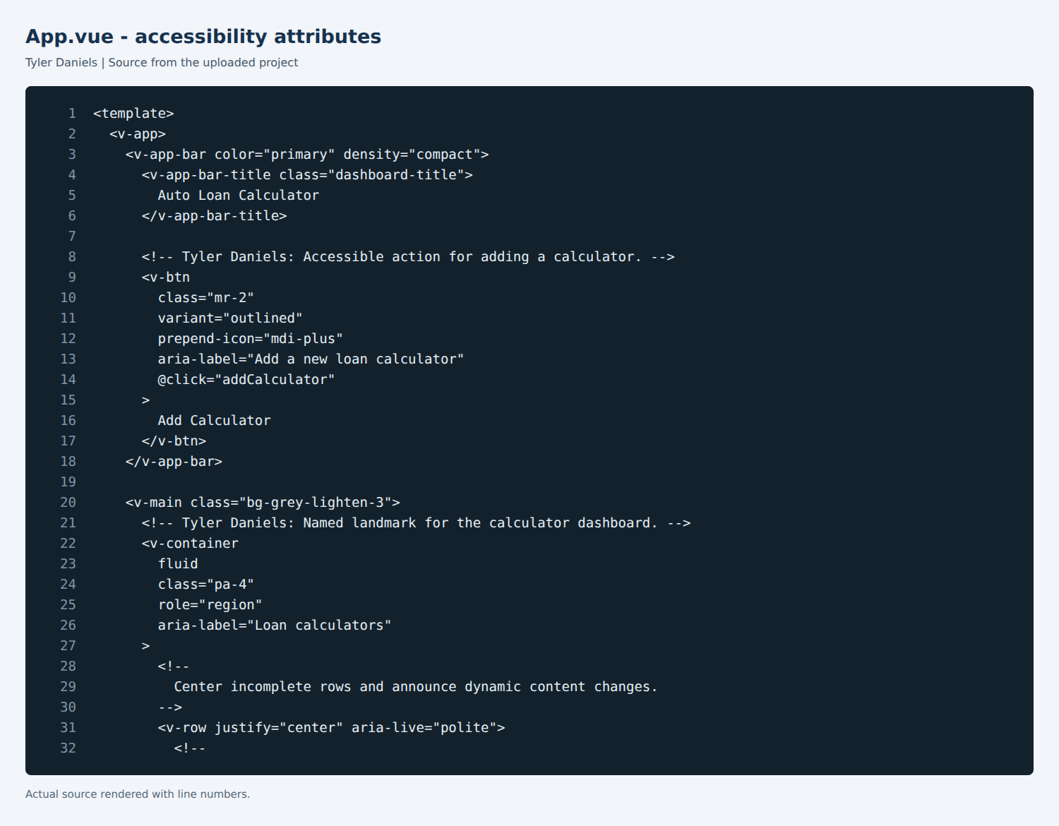
To improve responsiveness, I updated the parent grid that contains the calculator cards. Each card uses cols="12" for a single-column mobile layout, sm="6" for two columns on tablets, and lg="4" for three columns on larger desktop screens. I added justify="center" so incomplete rows remain centered. This is visible in the tablet layout, where the third calculator appears beneath the first two. I also allowed the columns to shrink within the grid and reduced the application title’s font size on narrow screens. These changes preserve the existing calculator components and calculation logic while adjusting how the available space is used.
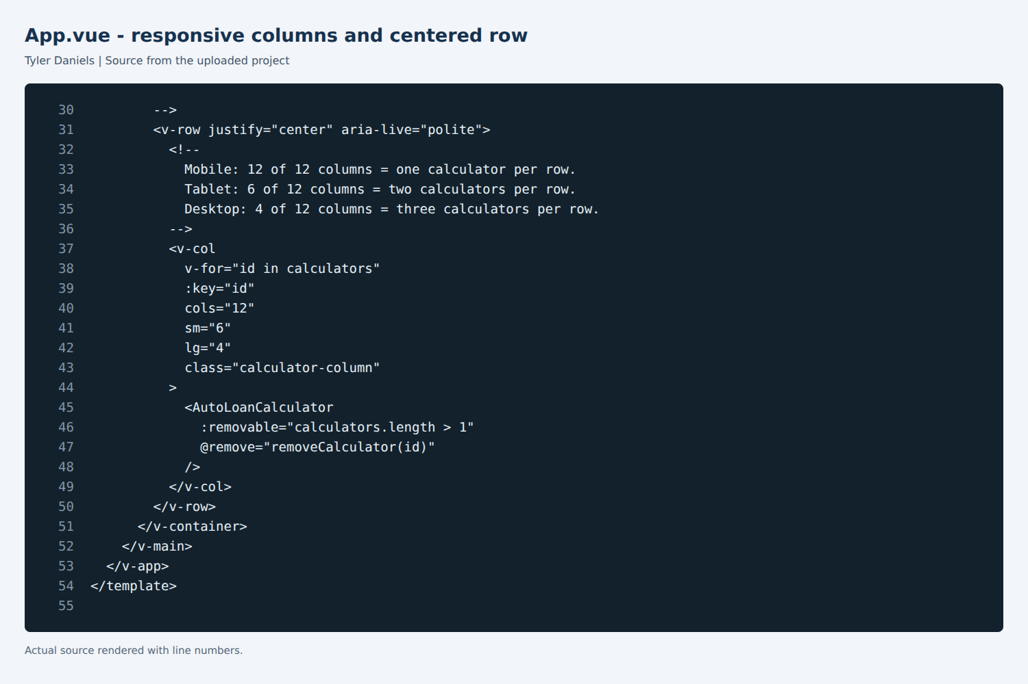
Validation used a browser with viewport widths of 390 pixels for mobile, 820 pixels for tablet, and 1440 pixels for desktop. At each width, three calculators were displayed to check the required column arrangement. The mobile view stacked the calculators vertically, the tablet view displayed two across, and the desktop view displayed all three in one row. The page also passed a check for horizontal overflow at each tested width. These checks demonstrate behavior at representative viewport sizes rather than on physical devices.
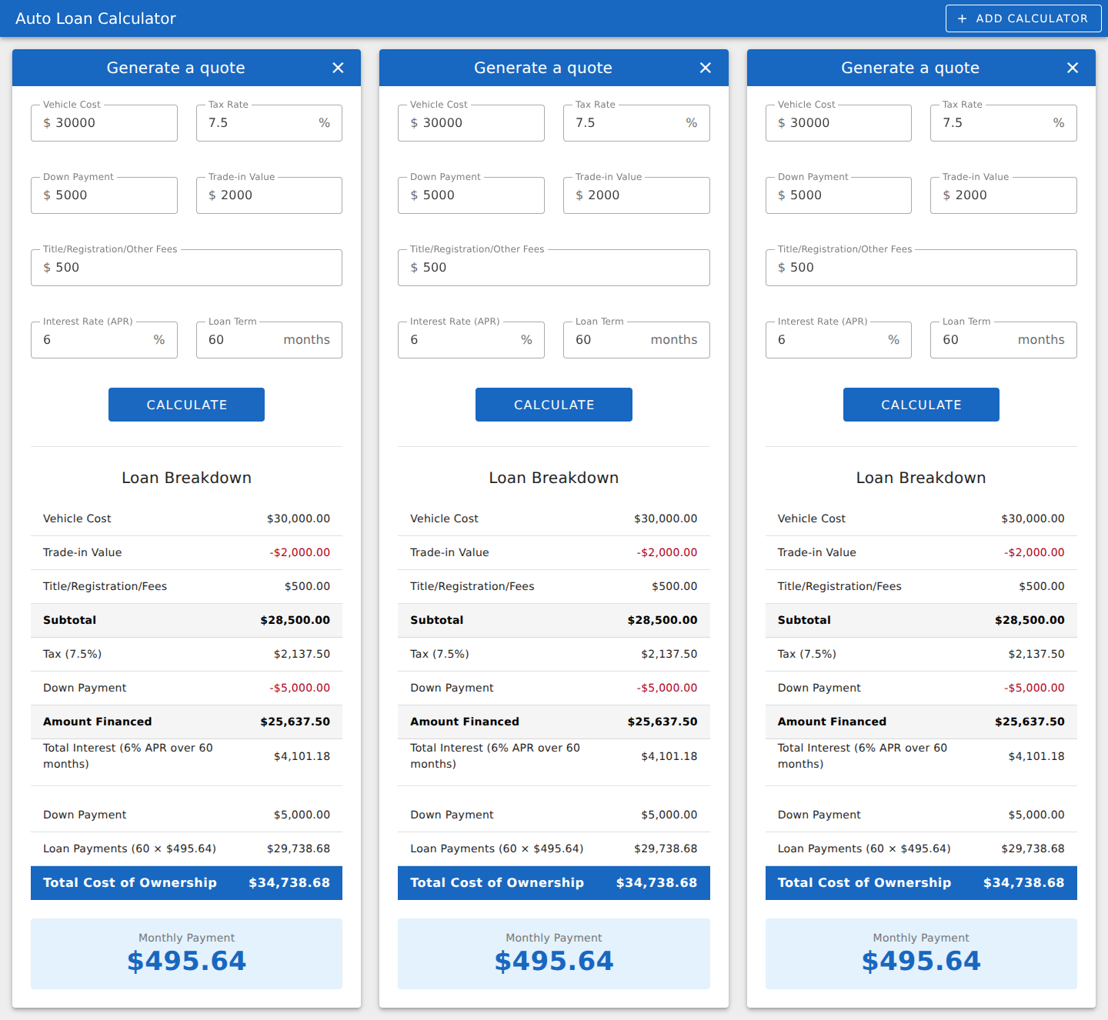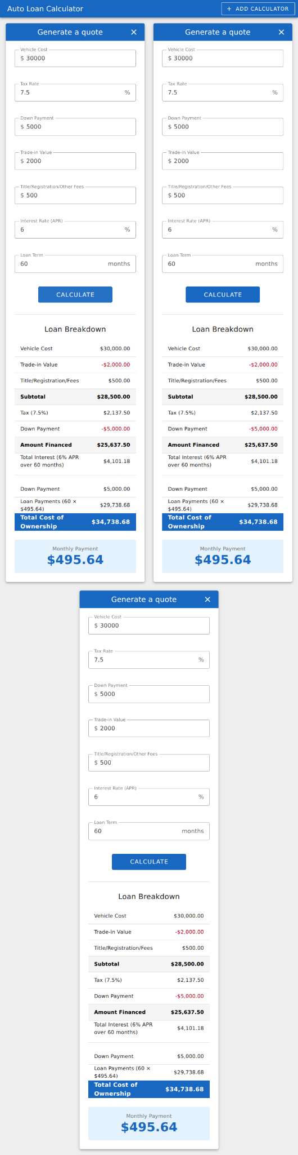
Functional testing used the same loan values in each calculator: a $30,000 vehicle cost, 7.5% tax, a $5,000 down payment, a $2,000 trade-in value, $500 in fees, 6% APR, and a 60-month term. Each calculator returned a monthly payment of $495.64 at all three viewport widths. Adding a fourth calculator and removing it also worked at each width. These results confirmed that the layout changes preserved the tested interactions and calculation output. The production build completed successfully, and no JavaScript page errors were recorded during the browser checks.
This activity showed me that responsive design involves both presentation and behavior. The grid needs to adapt to the available space while keeping the same controls and results accessible. The screenshots document the layout at each tested width, while the interaction checks provide evidence that the application continues to work as its layout changes. Further keyboard and screen reader testing would help evaluate accessibility beyond the ARIA attributes and visual checks completed here.

